**Building Apache Docker container Image(I used GitHub Actions to automate the build and push to Dockerhub)**

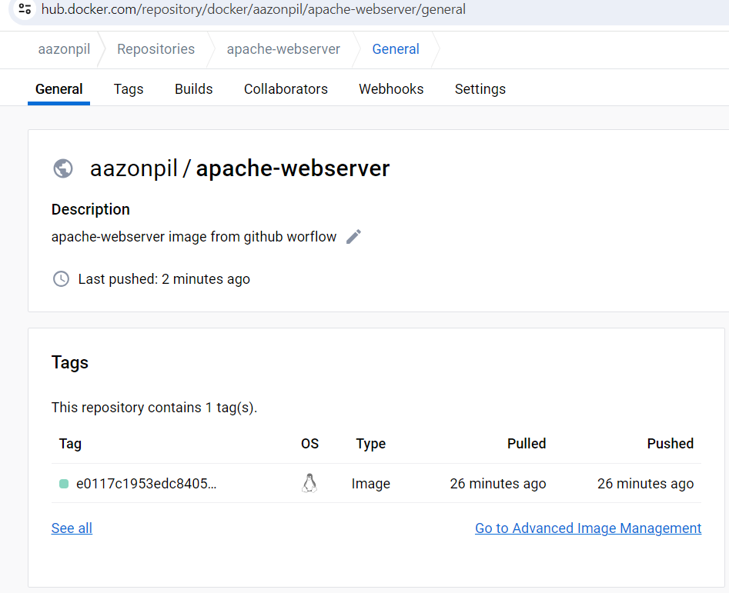

PULLL FROM: docker pull aazonpil/apache-webserver:4845a316e30c0189234f2d29bce1d36308d45e3b

<https://hub.docker.com/repository/docker/aazonpil/apache-webserver/general>